*“Swing With The Ques”*

*and Help the Kids*

*11th Annual Phil Ferguson Memorial Golf Tournament*

*Sponsored by*

*The Charles Drew Memorial Scholarship Fund, Inc*

*&*

*Gamma Pi Chapter, Omega Psi Phi Fraternity, Inc*

*Andrews AFB Golf Courses, Maryland 20762*

*Friday, June 26, 2015*

*7:00 a.m. Start of Registration - 9:00 a.m. Shotgun Start*

*Format: 4 Person Scramble*

*Many prizes (1st, 2nd & 3rd place, Longest Drive, Closest to the pin, door prizes,*

*and “Goodie” Bag)*

*Cost: $****125.00 Civilians, $115 Military & DoD, $100 AAFBC members(member # required) - Includes: Greens fee ♦ cart ♦ beverages on the course ♦ buffet awards luncheon ♦ Prizes ♦ Driving Range***

***For information please contact Marion Massey (301)736-1980 (***[***mhmassey@verizon.net***](mailto:mhmassey@verizon.net)***)***

***or Donald Herring, Sr. (301)980-0240 (herringdon@verizon.net)***

***Please send registration fee and requested information to address below by June 8, 2015.***

***All proceeds to benefit the Charles Drew Memorial Scholarship Fund, Inc.,***

***a 501(c)(3) non-profit corporation.***

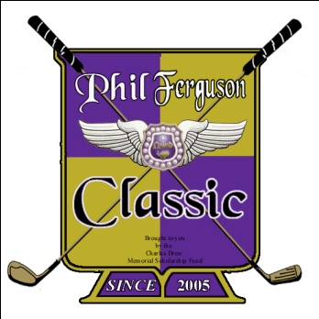

**Registration Form (register online at Gammapi.org)**

|  |  |  |  |
| --- | --- | --- | --- |
| Golfer Name | e-Mail Address | Drivers License No.* | State* |
|  |  |  |  |
|  |  |  |  |
|  |  |  |  |
|  |  |  |  |

* Required if you do not have base access.

**Total Enclosed: $**

Make check(s) payable & mail to:

CDMSF, Inc

P O Box 4432

Capitol Heights, MD 20791

***Note: Andrews AFB Security requires that all civilian tournament golfers provide driver's license number as a condition of entry. Golfers that fail to provide driver's license number may be denied entry.***