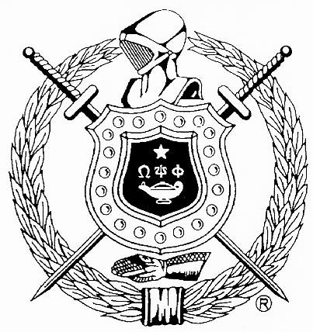
The Charles Drew Memorial Scholarship Fund, Inc.
In Association with
Gamma Pi Chapter, Omega Psi Phi Fraternity, Inc.
Post Office Box 4432
Capitol Heights, Maryland 20791-4432

SCHOLARSHIP APPLICATION
INFORMATION SHEET
(12th Grade Applicants)

The Gamma Pi Chapter of Omega Psi Phi Fraternity, Incorporated, is chartered in Prince George’s County, Maryland. Its hopes and aspirations for the education of our youth are consistent with other Omega Men throughout the world. Accordingly, the men of Gamma Pi Chapter established a memorial scholarship fund in honor of Dr. Charles R. Drew, a deceased fraternity brother of international acclaim for his contributions to science and medicine. Students from Prince George’s County that apply for the scholarships (up to $1,500 per scholarship awarded), are judged by the Scholarship Committee and the best qualified are selected for the awards based on the following criteria:

Eligibility:
A candidate must be a prospective high school graduate, who has applied to enter an accredited college, university or institution of higher learning on a full-time basis.

Scholastic Achievement:
A candidate must have a more than satisfactory academic record with a 3.0 grade point average or better.

Number and Amount:
The total number and amount of scholarships will be determined by The Charles Drew Memorial Scholarship Fund, Inc. and Gamma Pi Chapter.

Non-Discriminatory Basis:
Scholarships will be awarded on a non-discriminatory basis regardless of race, sex, religious beliefs, or other non-merit factors.

Transcript and Letters of Recommendation:
A candidate’s most recent official high school transcript and letters of recommendation from references listed on the Scholarship Application must be attached to the application.

Financial Need:
Basis of your family’s financial need could be considered. (See Scholarship Application)

Essay Themes:

- “Are African Americans granted the civil liberties specified in the United States Constitution?”

Submission of Application:
Candidates desiring to apply for this scholarship must submit their completed application with attachments to:

The Charles Drew Memorial Scholarship Fund, Inc.
Gamma Pi Chapter, Omega Psi Phi Fraternity, Inc.
Post Office Box 4432
Capitol Heights, MD 20791-4432

Deadline: Applications must be received or postmarked no later than midnight 31 March 2018.
Recipients will be recognized at their respective Senior High School Awards Programs, Gamma Pi Project ENRICH Closing Ceremony and the Gamma Pi Achievement Week celebration.

