The Charles Drew Memorial Scholarship Fund, Inc.
Gamma Pi Chapter
Omega Psi Phi Fraternity, Inc.
Post Office Box 4432
Capitol Heights, Maryland 20791-4432

Scholarship Application

Attach your
Senior photograph
here

All fields required to be complete:

1. Name:
Last First Middle Telephone Number

2. Address:
Street

City State Zip

3. Date of birth: Sex: Male Female: Email:
Month Day Year

4. Name of high school now attending:

5. Parents/Guardians: Father

Mother

Guardian

Address of parents or guardian:

6. College you plan to attend:

a. Have you applied? b. Have you been accepted? c. Opening date of school:

7. ACT Scores:

8. SAT Scores: Critical Reading Mathematics Writing

9. Current class standing:

10. Cumulative Grade Point Average: (Please include an official/unopened transcript)

11. Have you served as a volunteer, tutor, mentor, peer mediator, or advisor in High School? If so, please explain.

CDMSF Form Revised 11/18 Page 1

12. Immediate family income information: Applicant must provide documentation to support gross income listed below (e.g., Current W-2 form).

Name Education Occupation Gross Income

Father

Mother

Guardian(s)

13. List extracurricular activities, e.g., dramatics, musical, publications, student government, athletics, other.

14. List offices held and honors received:

15. In which extracurricular activities do you expect to participate while in college?

16. Submit a TYPED essay, on a separate sheet, consisting of 300-500 words on the essay theme identified on the Scholarship Application Information Sheet.

17. Please attach two (2) current (in this school year) letters of recommendation from your pastor, current teachers and/or counselors with at least one (1) coming from your school.
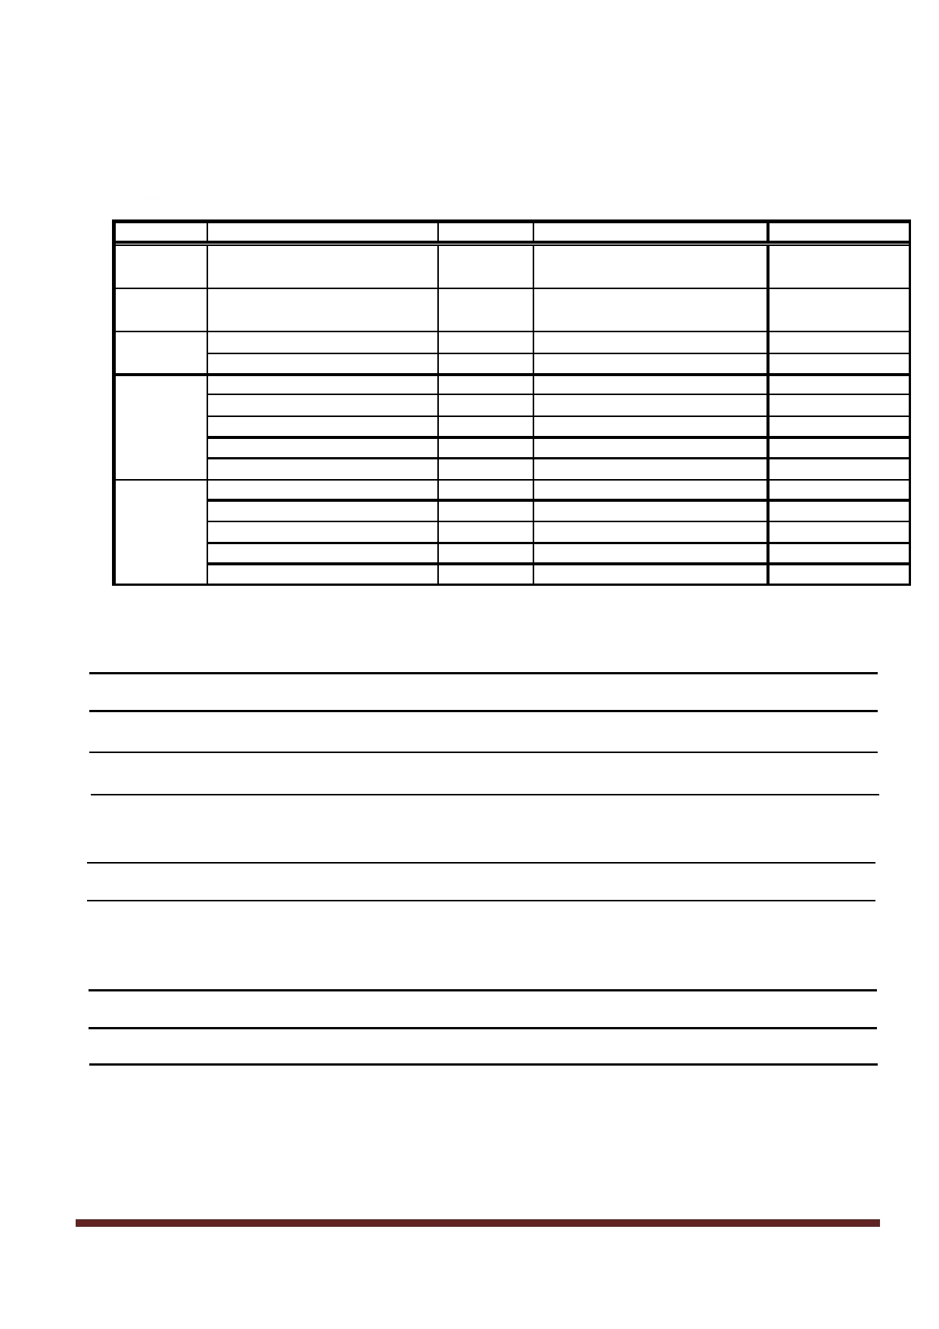
CDMSF Form Revised 11/18 Page 2

18. Submit a TYPED statement, on a separate sheet, in 100-150 words, please state why you should be a recipient of this scholarship. Your statement should include how these funds can assist you in achieving your career goals. Be specific as possible.

Please use additional sheets if needed!!

19. Certification and Authorization. We hereby certify that the information provided to complete this application is true and correct and authorize use of the photograph and certain information (students name, high school, university, and field of study) submitted with this application by The Charles Drew Memorial Scholarship Fund, Inc. and Gamma Pi Chapter in promoting its Scholarship Program.

Date: Signature of Applicant

Signature of Parent or Guardian

All materials must be received or post marked no later than midnight April 7, 2019.

**Note: Continuing-Student Scholarship Program. If you are successful and receive a scholarship for your first year of academic study, you will be eligible to apply for and receive a continuing-student scholarship during your subsequent years in college. These scholarships will be awarded on a competitive basis if you maintain satisfactory academic progress (3.0 grade point average and in good standing with your institution) towards your degree. Ensure that your latest contact information is provided to The Charles Drew Memorial Scholarship Fund, Inc. so that you can receive continuing-student information and applications.

Mail To:
The Charles Drew Memorial Scholarship Fund, Inc.
Gamma Pi Chapter, Omega Psi Phi Fraternity, Inc.
Post Office Box 4432
Capitol Heights, MD 20791-4432

CDMSF Form Revised 11/18 Page 3

