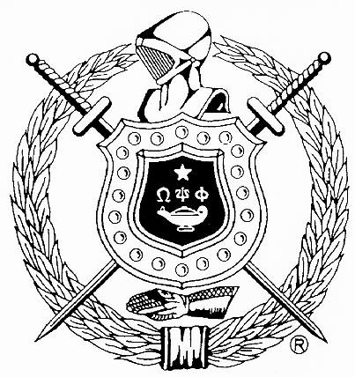
The Charles Drew Memorial Scholarship Fund, Inc.
In Association with
Gamma Pi Chapter, Omega Psi Phi Fraternity, Inc.
Post Office Box 4432
Capitol Heights, Maryland 20791-4432

SCHOLARSHIP APPLICATION
INFORMATION SHEET
(Continuing Student Applicants)

The Gamma Pi Chapter of Omega Psi Phi Fraternity, Incorporated, is chartered in Prince George's County, Maryland. The men of Gamma Pi Chapter established the Charles Drew Memorial Scholarship Fund, Inc. in honor of Dr. Charles R. Drew, a deceased fraternity brother of international acclaim for his contributions to science and medicine. All applicants must have previously been a recipient of the Charles Drew Memorial Scholarship Fund, Inc. scholarship. Scholarships will be awarded up to $1,500 and are judged by the Scholarship Committee. The best qualified are selected for the awards based on the following criteria:

Eligibility:
A candidate must be a continuing student who has previously been a recipient of the Charles Drew Memorial Scholarship Fund, Inc. scholarship, and is currently enrolled at an accredited college, university or institution of higher learning on a full-time basis. A candidate must also submit a completed application prior to the application deadline listed below.

Scholastic Achievement:
A candidate must have a more than satisfactory academic record with a 3.0 grade point average or better.

Number and Amount:
The total number and total amount of the scholarships awarded will be determined by the Charles Drew Memorial Scholarship Fund, Inc.

Non-discriminatory Basis:
Scholarships will be awarded on a non-discriminatory basis regardless of race, sex, religious beliefs, or other non-merit factors.

Transcript and Letters of Recommendation:
A candidate’s most recent official institution transcript and letters of recommendations from references listed on the Application for Scholarship must be attached to the application.

Submission of Application:
Candidates desiring to apply for the scholarship must submit their application and attachments to:

The Charles Drew Memorial Scholarship Fund, Inc.
Gamma Pi Chapter, Omega Psi Phi Fraternity, Inc.
Post Office Box 4432
Capitol Heights, MD 20791-4432

Deadline: All materials must be received or post marked no later than midnight, June 30, 2018.
Recipients will be recognized at the Gamma Pi Chapter Achievement Week celebration in November.

For information on the Charles Drew Memorial Scholarship Fund, Inc., please visit the web site at www.charlesdrewmsf.org.

